**FACULTY OF ENGINEERING, DESIGN AND TECHNOLOGY**

DEPARTMENT OF COMPUTING AND TECHNOLOGY

ADVENT 2024 SEMESTER OOP COURSEWORK PROJECT REPORT

PROGRAM: BSCS, BSDS 2:1

COURSE: Object-Oriented Programming

COURSE LECTURER: Ian Raymond Osolo

PROJECT TITLE: HOTEL RESERVATION SYSTEM

*Submitted by*

|  |  |  |  |
| --- | --- | --- | --- |
| S/N | Reg Number | Name | Signature |
| 1. | S23B23/028 | KISA EMMANUEL |  |
| 2. | S23B23/006 | ARAPTA HILDA LUCKY |  |
| 3. | M23B23/025 | MUCUNGUZI GODFREY |  |
| 4. | S23B23/075 | ABSOLOM ORIANGA |  |
| 5. | S23B23/013 | TENDO CALVIN |  |

Date Submitted: …………………………………

**1.0 Abstract**

This project aims to develop a hotel reservation system using Python, applying object-oriented programming (OOP) principles. The system will provide a user-friendly interface for both hotel staff and guests to manage room reservations efficiently. Key functionalities include:

* Room Management: Creating, modifying, and deleting room records with details such as room type, capacity, and price.
* Reservation Management: Booking rooms, canceling reservations, and generating reservation confirmations.
* Guest Management: Maintaining a database of guest information for future reference.
* Payment Processing: Simulating payment transactions and generating invoices.

By leveraging OOP concepts such as inheritance, polymorphism and encapsulation, the system will be maintainable and scalable. The project will demonstrate the practical application of OOP principles in reference to what we are being taught.

**2.0 Introduction, problem statement, and project objectives**

**Introduction.**

Due to advancements in technology, the hospitality industry is constantly evolving. To remain competitive, hotels must adopt innovative solutions to streamline their operations and enhance guest experiences. In this project we aim to develop a comprehensive hotel reservation system that leverages object-oriented programming (OOP) principles to create a flexible, efficient and user-friendly application. By applying OOP concepts, the system will be maintainable and scalable facilitating future enhancements and adaptations.

**Problem Statement.**

Traditional hotel reservation systems often suffer from inefficiencies, such as manual data entry, overbooking, and difficulty in tracking reservations. These inefficiencies can lead to decreased customer satisfaction, loss of revenue, and operational challenges.

**Project Objectives.**

This project aims to address these challenges by developing a hotel reservation system that incorporates the following objectives:

1. Implement Object-Oriented Design:

* Design and implement a class-based structure to model real-world entities like rooms, guests, and reservations.
* Use inheritance and polymorphism to create a flexible and extensible system.
* Encapsulate data and behavior within classes to promote modularity and code reusability.

2. Automate Reservation Process:

* Develop a user-friendly interface for the user to search for available rooms, make reservations (check-ins) and view booking details.
* Implement a backend system to manage room availability, assign rooms to guests, and generate booking confirmations.

3. Manage Room Inventory:

* Create a system to track room types, capacities, and pricing information.
* Implement a mechanism to update room availability in real-time based on bookings and check-ins/check-outs.

4. Process Payments:

* Integrate with a payment gateway to facilitate online payments.
* Implement features for handling different payment methods (credit card, debit card, mobile payments).

By achieving these objectives, this project will contribute to the development of a robust and efficient hotel reservation system that benefits both hotel staff and guests.

**3.0 Methods, tools and designs used for the project**

**1. Methods**

> The hotel reservation system was developed using the Object-Oriented Programming (OOP) paradigm, which provides a reusable approach to software development. Key OOP concepts applied include:

Classes and Objects: The system is organized around classes that represent real-world entities such as Hotel, Room, Customer, and Reservation. Objects of these classes interact to handle different functionalities.

* Encapsulation: Sensitive data such as customer payment details are encapsulated within classes to ensure security and data integrity.
* Inheritance: The system uses inheritance to create a hierarchy of room types (e.g., Double Room, Single Room, Suite Room), which all inherit common properties from a base Room class.
* Polymorphism: The system leverages polymorphism to handle various room booking types, allowing for flexible code that can accommodate different room configurations.

**2. Tools**

Programming Language: Python

IDE and Development Tools: VS Code.

Libraries: Tkinter for Graphical User Interface, Powerful Image Processing (PIL) used for image processing.

**3. Designs**

Presentation Layer: A Tkinter-based desktop interface was provided for hotel staff.

Class Diagram; The main classes include:

* Hotel: Manages hotel details and overall system coordination.
* Room: Handles room details, availability status, and pricing.
* Guest: Manages customer information and booking history.
* Reservation: Processes booking requests, assigns rooms, and handles payment transactions.

In addition, a Factory Pattern was used to create different types of rooms (e.g., Double room, Single room, Suite room) dynamically, improving code flexibility and maintainability.

User Interface Design: For hotel staff, the desktop interface includes a dashboard for managing reservations, checking room statuses.

**4.0 Results**

Project Description

This project is a hotel reservation system developed using Object-Oriented Programming (OOP) principles in Python, aimed at addressing the limitations of traditional hotel management practices. These practices, often characterized by manual data entry, risk of overbooking, and difficulties in tracking reservations, present challenges that can reduce customer satisfaction, cause revenue loss, and create operational inefficiencies. The developed system offers a streamlined, automated approach to managing hotel reservations, enhancing both customer experience and hotel operational efficiency.

**Project Justification**

The hotel reservation system designed in this project successfully meets the identified objectives and solves the problem of inefficient reservation management through a robust, modular, and scalable software structure.

1. Object-Oriented Design Implementation:

The system uses a class-based structure to model essential hotel entities, such as rooms, guests, reservations, and payments. Each entity is encapsulated within its respective class, which defines relevant attributes and methods. This structured approach improves modularity and reusability, making it easier to extend and maintain the system.

Inheritance and polymorphism enable future flexibility. For instance, the Room class can be extended into specialized room types like Single room or Double room, allowing for customized pricing or features. Similarly, payment methods can be expanded with subclasses for different transaction types, which makes the system adaptable for varying business needs.

1. Automated Reservation Process:

A user-friendly GUI interface built with Tkinter allows users to interact seamlessly with the system. The GUI offers straightforward functions to search for available rooms, make reservations, check in, and review booking details. The system’s backend manages real-time room availability and ensures that only available rooms are shown for new reservations. This design avoids overbooking by automatically marking rooms as unavailable upon booking and updating the status upon check-out.

1. Efficient Room Inventory Management:

The system enables tracking of different room types, capacities, and pricing through the Room class. Real-time room status updates allow the hotel to monitor inventory and manage availability as guests check in and out. The Hotel class provides a centralized system for managing all rooms, with features to check which rooms are free or occupied at any time. This improves the staff’s ability to manage inventory and avoid errors that could lead to guest dissatisfaction or lost revenue.

1. Integrated Payment Processing:

The project incorporates a Payment class that facilitates handling payments, including different payment methods such as credit cards and mobile payments. While integration with a live payment gateway is yet to be implemented, the design supports future extension for online payments, allowing the hotel to securely process transactions directly within the system. By centralizing and automating payments, the system reduces potential errors associated with manual entry and helps maintain accurate financial records.

1. Achievement of Objectives:

This system effectively meets the objectives outlined, demonstrating how OOP principles can be applied to create a functional, flexible, and scalable reservation solution. By automating tasks previously prone to human error, such as room booking, availability tracking, and payment processing, the project provides a streamlined and efficient workflow for hotel staff and a satisfying experience for guests.

**5.0 Conclusion**

The hotel reservation management system will optimize operations, enhance guest experience and maximizes revenue through reducing through manual errors, overbooking and time consuming processes.

This highlights the core purpose of a hotel management system:

To streamline processes, improve guest satisfaction and increase profitability.

We can then use this to explain how the system achieves these goals, such as:

* Streamlining Operations: Automating tasks like reservations, check-ins, and check-outs, reducing manual effort and potential errors.

* Enhancing Guest Experience: Providing personalized services, efficient check-in/out processes, and real-time updates on room availability and services.

* Maximizing Revenue: Optimizing room pricing, maximizing occupancy rates, and implementing effective revenue management strategies.

By focusing on these key areas, a well-designed hotel management system can significantly contribute to the overall success of a hotel.

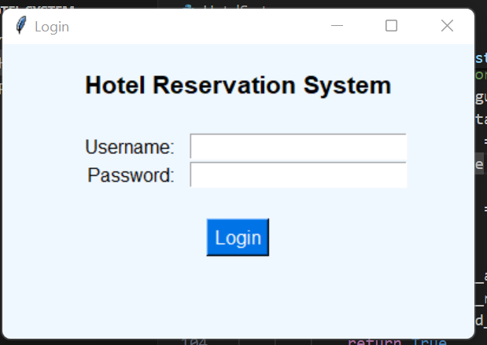

This figure 1 represents the login page.

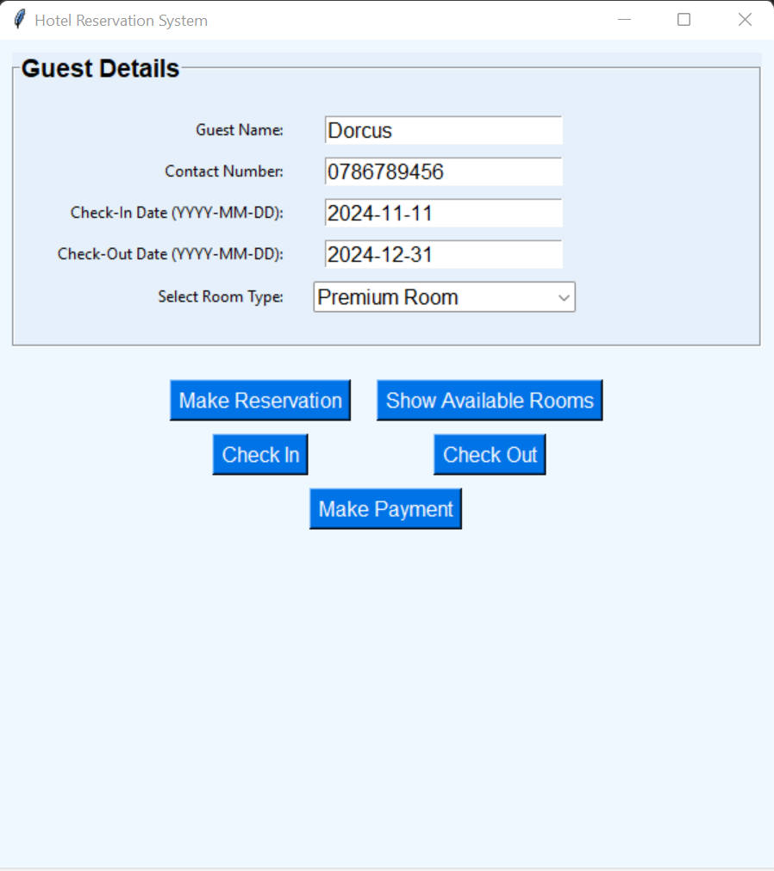

This figure 2 represents the dashboard for the hotel management system.